**Session report 15/11/2022:**

*LABAUVIE – RAFFAELLI EVA*

*ROB3*

The goal of today’s session is to understand better how the auvidea card works.

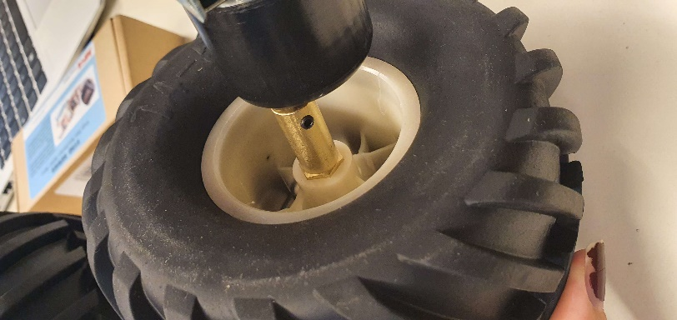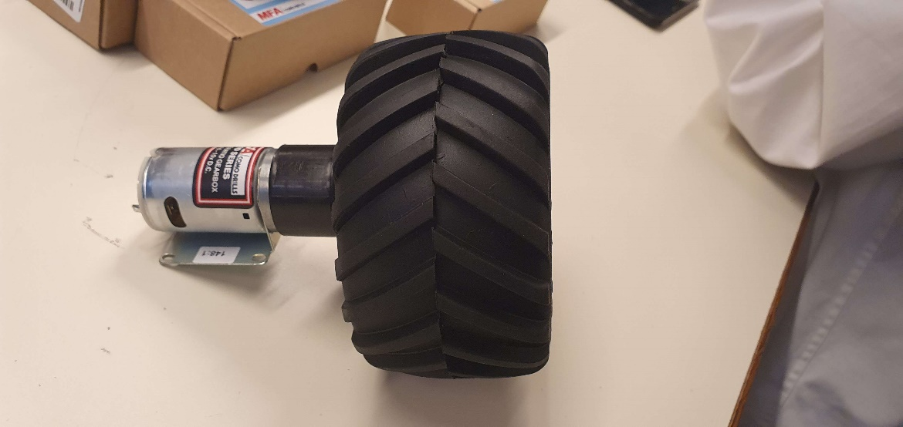Before anything else, as we received the wheels, we tried to assemble motor/wheels/adaptor with Hugo to see if it works properly.

We managed to make the whole system spin properly so it seems like it’s working properly.

Next step is getting started with the jetson nano card. To do so, I listened to Mr Fauvel that advised me on taking a look at the tutorials directly on the Nvidia site.

<https://developer.nvidia.com/embedded/learn/getting-started-jetson#tutorials>

<https://developer.nvidia.com/embedded/learn/jetson-ai-certification-programs#course_outline>